**Roll no : 160121748045**

**Name : D. Yakshith Naidu**

**Class: CSE[AIML]**

## AR/VR ASSIGNMENT-1

1]

## Case Study: Augmented Reality in Healthcare – Remote Surgery & Training



**Background Industry Setting:**

The healthcare industry is continuously evolving with technological advancements to improve patient care, medical training, and surgical precision. Traditional medical procedures rely on 2D imaging and direct physician expertise, often limiting the accuracy and accessibility of complex surgeries. However, Augmented Reality (AR) has revolutionized the healthcare industry by providing real-time visualization, remote surgical assistance, and interactive medical training, ultimately improving patient outcomes.

**The Need for Innovation:**

The healthcare industry faces several challenges that AR technology aims to address:

1. Limited Surgical Precision: Traditional surgeries depend on 2D imaging and physical examination, reducing accuracy in complex procedures.
2. Inefficient Medical Training: Medical students and surgeons often rely on textbooks and static models for learning, limiting hands-on experience.
3. Remote Accessibility Barriers: Many regions lack expert surgeons, making it difficult for patients to access high-quality surgical care.
4. High Error Rates in Complex Surgeries: Without enhanced visualization, surgeons face difficulties in performing intricate procedures, increasing the risk of errors.

To overcome these challenges, MedTech Solutions implemented AR technology to enhance remote surgeries, medical education, and real-time surgical guidance.



**Solution: AR-Powered Surgical Assistance & Training What is it?**

MedTech Solutions developed an AR-assisted surgical guidance and training platform that enables surgeons to overlay critical anatomical structures in real-time while performing operations. The system integrates Microsoft HoloLens and AI-powered AR models to assist doctors and improve medical precision.

**How It Works:**

1. AR-Assisted Remote Surgery
   * Surgeons wear AR headsets (e.g., Microsoft HoloLens, Magic Leap) to visualize 3D anatomical models directly on the patient.
   * AI-driven overlays guide surgeons through complex procedures by highlighting critical areas and displaying step-by-step instructions.
   * 5G and cloud-based telemedicine allow expert surgeons to assist remote doctors in real-time from different locations.
2. Medical Training & Simulation
   * Medical students use AR-based 3D models to study human anatomy in an interactive manner.
   * Haptic feedback gloves provide hands-on experience for practicing surgical techniques.
   * Real-time performance tracking helps students improve precision and technique through AI-powered feedback.
3. Real-Time Decision Support System
   * AR overlays provide real-time patient vitals, X-ray scans, and MRI images directly in the surgeon’s field of view.
   * AI algorithms detect anomalies, alerting surgeons to potential risks during procedures.
4. Enhanced Collaboration & Data Sharing
   * Multi-user AR environments allow doctors across different locations to collaborate in real-time during surgery.
   * Patient data and surgical insights are stored in the cloud, allowing for future case studies and AI-driven improvements.



**Results and Outcomes**

1. 40% Reduction in Surgical Errors
   * AR-assisted surgeries improved precision and accuracy, reducing complications in complex procedures.
   * Real-time overlays provided better anatomical visualization, lowering error rates.
2. 60% Improvement in Medical Training Efficiency
   * AR-based simulations allowed medical students to practice in a risk-free environment before performing real surgeries.
   * AI-driven feedback helped students improve surgical techniques faster.
3. 30% Faster Surgery Completion Time
   * Surgeons had instant access to critical patient data and visual guidance, reducing decision-making time.
   * Enhanced visualization allowed for faster and more efficient procedures.
4. Increased Access to Remote Medical Expertise
   * Rural and underserved regions benefited from remote AR-assisted surgeries, allowing expert surgeons to guide local doctors in real-time.



**Challenges**

1. High Implementation Costs
   * AR devices and AI-powered medical platforms require significant investment, making adoption slow in small hospitals and developing countries.
2. Technology Adaptation Resistance
   * Some surgeons hesitate to trust AR-based systems over traditional methods due to lack of familiarity.
   * Training programs are required to help doctors adapt to new AR-based workflows.
3. Internet & Hardware Limitations
   * AR-based remote surgeries depend on high-speed 5G networks, which are not available in all locations.
   * Battery life and processing power of AR headsets need further advancements for extended surgical procedures.



# 2]

## VR Tools for 3D Art – Detailed Overview

Creating 3D art in VR has revolutionized digital sculpting, painting, animation, and design. These tools provide immersive workflows, allowing artists to interact directly with their creations in virtual space. Below is a detailed breakdown of each tool, their features, applications, and ideal use cases.

## Tilt Brush (by Google) – VR Painting & Illustration

**Best for: Freeform 3D painting, neon effects, immersive illustrations**

### Overview:

Tilt Brush is a VR painting tool that lets artists draw and paint in 3D space. It uses gesture- based controls, allowing users to create expressive artwork with dynamic brush strokes such as fire, neon lights, and smoke effects.

### Key Features:

* + **3D Brush Strokes** – Paint in **360-degree space** using a variety of textures and lighting effects.
  + **Motion-Responsive Brushes** – Create animated strokes with effects like **glow, fire, stars, and electricity**.
  + **Intuitive UI** – Easy to use with controllers, making it great for beginners and professionals alike.
  + **VR Live Art Performances** – Used by digital artists for **live painting showcases**.

### Applications:

**Concept Art & Storyboarding** – Quickly create **immersive 3D sketches**.

**VR Art Installations** – Used in **museums and exhibitions** to create interactive art.

**Live Performances & Animation** – Artists can paint while **streaming their VR sessions**. **Ideal for: Illustrators, VR concept artists, immersive designers.**

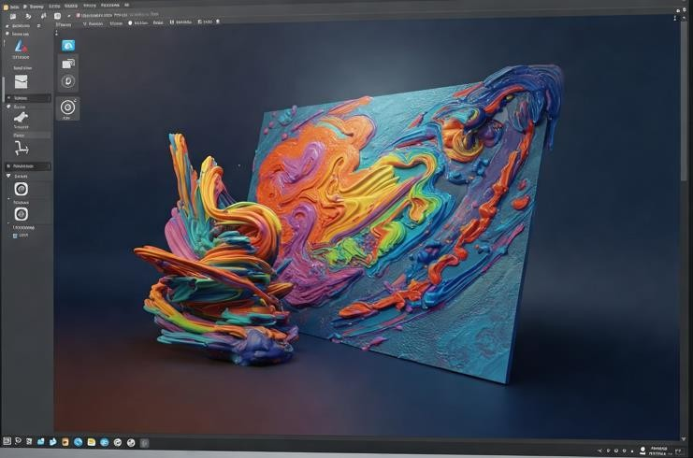

## Quill (by Smoothstep) – VR Animation & Storyboarding

**Best for: Frame-by-frame VR animation, comic-style storytelling**

### Overview:

Quill is a VR illustration and animation tool designed for hand-drawn, frame-by-frame animation inside VR. It is primarily used to create animated 3D comics, virtual paintings, and immersive stories.

### Key Features:

* + **Hand-Drawn 3D Animation** – Artists can create **frame-by-frame animated sequences**.
  + **Vector-Based Strokes** – Ensures **clean, scalable artwork**.
  + **VR Storyboarding & Comics** – Used to create **immersive 3D comic books and animated short films**.
  + **Dynamic Camera Movements** – Adjust camera angles and movements for

**cinematic storytelling**.

### Applications:

**VR Animation Production** – Used in VR films like **"Dear Angelica"** for hand-drawn animation.

**Storyboarding & Pre-Visualization** – Helps animators visualize scenes in **3D space**.

**VR Comics & Interactive Stories** – Artists can **create fully explorable VR story worlds**. **Ideal for: 2D/3D animators, storyboard artists, motion designers.**

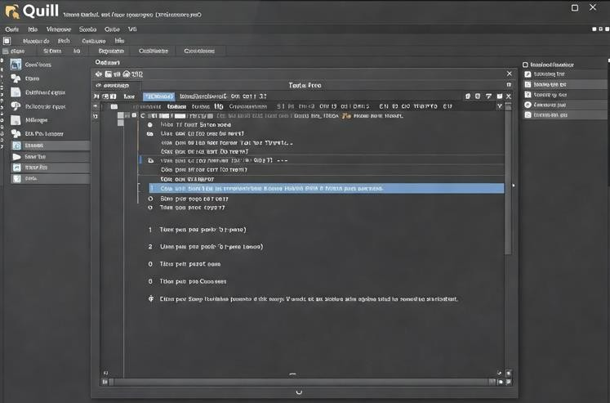

## Gravity Sketch – 3D Concept Art & Industrial Design

**Best for: Product design, automotive sketching, architecture**

### Overview:

Gravity Sketch is a VR-based 3D sketching and modeling tool that enables designers to create complex wireframes, surfaces, and solid 3D models. It is widely used in industrial design, automotive, and architecture.

### Key Features:

* + **Precision 3D Sketching** – Draw and design **in full 3D space** with **accurate scale and perspective**.
  + **Surface & Volume Modeling** – Supports both **wireframe and solid modeling**.
  + **Multi-User Collaboration** – Designers can **work together in real-time** within the same VR environment.
  + **CAD Export Support** – Models can be exported to **Blender, Maya, ZBrush, Rhino, and CAD software**.

### Applications:

**Automotive & Product Design** – Used by companies like **Ford and Nissan** for car prototyping.

**Architecture & Interior Design** – Architects can **visualize structures in VR**. **Concept Art & Fashion Design** – Used for **early-stage 3D design iterations**.

**Ideal for: Industrial designers, architects, fashion designers, product engineers.**

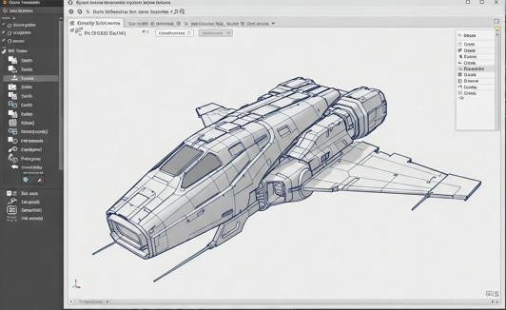

## Oculus Medium (by Adobe) – VR Sculpting & Modeling

**Best for: Organic 3D modeling, digital clay sculpting**

### Overview:

Oculus Medium (now part of Adobe Substance 3D Modeler) is a VR sculpting tool that mimics traditional clay modeling. It allows artists to sculpt detailed 3D characters, creatures, and environments.

### Key Features:

* + **Clay-Like Sculpting** – Create **organic 3D shapes with realistic volume and depth**.
  + **Advanced Brush Tools** – Supports **smoothing, carving, and texturing**.
  + **VR Model Export** – Works with **Blender, ZBrush, Maya, and Substance Painter**.
  + **Hand Tracking & Precision Controls** – Provides fine **gesture-based sculpting**.

### Applications:

**Character & Creature Sculpting** – Used in **game design and film production**.

**High-Detail Environment Sculpting** – Create **landscapes, caves, and organic structures**. **Game & VR Asset Creation** – Used in **game studios for prototyping assets**.

**Ideal for: 3D modelers, game designers, character artists.**

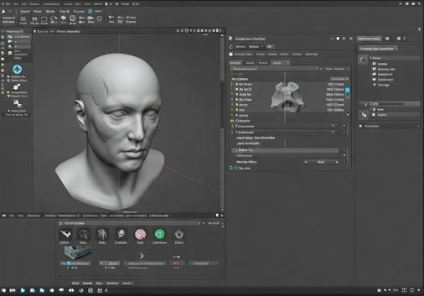

## Masterpiece Motion – VR Rigging & Animation

**Best for: Auto-rigging, motion capture, character animation**

### Overview:

Masterpiece Motion is a VR-based rigging and animation tool that enables fast character rigging and real-time animation. It eliminates the need for manual weight painting and complex rigging.

### Key Features:

* + **Automatic Rigging** – Quickly add **joints and bones** to 3D models.
  + **Motion Capture Support** – Records **VR-based movement** for **realistic character animations**.
  + **Animation Timeline** – Adjust keyframes and movements **inside VR**.
  + **Exports to Game Engines** – Works with **Unity, Unreal Engine, Blender, and Maya**.

### Applications:

**Character Animation & VR Game Development** – Used to create **animated characters in minutes**.

**Motion Capture for Films & Games** – Converts **body movements into digital animations**.

**3D Asset Rigging** – Speeds up the **character development pipeline**.

**Ideal for: Game developers, animators, indie creators.**

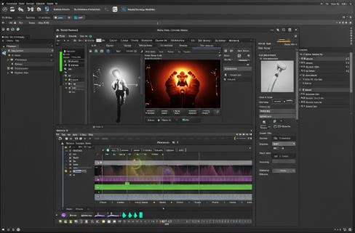

# 3]

**Game Engine:**

A game engine is a software framework used to develop video games, VR experiences, and interactive simulations. It provides essential tools and pre-built functionalities that allow developers to create realistic and immersive environments efficiently.

### Core Components of a Game Engine:

1. **Rendering Engine** – Processes **3D graphics, lighting, and textures**.
2. **Physics Engine** – Simulates **gravity, collisions, and object interactions**.
3. **AI System** – Powers **NPC behavior, decision-making, and pathfinding**.
4. **Audio Engine** – Handles **3D spatial audio and sound effects**.
5. **Animation System** – Enables **realistic movement, character rigging, and facial expressions**.
6. **Multiplayer Networking** – Supports **real-time online gameplay and VR collaboration**.

Game engines are essential in VR because they handle the complexities of real-time rendering, motion tracking, and immersive interaction.

## Importance of Game Engines in VR

### Real-Time Rendering & Immersion

Game engines ensure high-quality visuals at high frame rates to maintain immersion and prevent motion sickness in VR.

Example: Unreal Engine’s Lumen technology enables real-time global illumination for ultra- realistic VR worlds.

### Physics & Realistic Interactions

VR applications require accurate object physics to enhance immersion.

Example: Unity’s RigidBody Physics enables realistic object grabbing, throwing, and collisions in VR.

### Motion Tracking & Input Handling

Game engines provide built-in support for hand tracking, controllers, eye tracking, and body movement in VR.

Example: Unity XR Toolkit integrates gesture-based hand interactions in Meta Quest and HTC Vive.

### Cross-Platform VR Development

Game engines allow developers to build once and deploy across multiple VR devices. Example: OpenXR integration in Unreal Engine & Unity ensures compatibility with HTC Vive, PlayStation VR, and Meta Quest.

### AI-Powered NPCs & Realistic Environments

AI-driven characters improve VR gaming and training simulations.

Example: Half-Life: Alyx (Unreal Engine) uses AI-powered NPCs that react to player movements in VR.

### Multiplayer & Social VR

Game engines allow real-time multiplayer networking, making VR social spaces and online games possible.

Example: VRChat (Unity Engine) supports thousands of players in interactive VR worlds.

## Best Game Engines for VR Development

**1️.Unity –** The Most Popular VR Game Engine

Best for: VR games, training simulations, AR/VR applications

**Why Unity for VR?**

* **Optimized for standalone VR headsets like Meta Quest & HTC Vive.**
* **Supports OpenXR, SteamVR, and Oculus SDK for easy integration.**
* **Large asset store & developer community for VR tools.**

**Example:**

**Beat Saber** – A VR rhythm game built in **Unity**.



### 2️.Unreal Engine – Best for High-End VR Graphics

Best for: AAA VR games, cinematic experiences, architectural visualization

**Why Unreal Engine for VR?**

* Photorealistic rendering using Nanite & Lumen.
* Blueprint visual scripting for easy VR development without coding.
* Powerful physics and AI tools for realistic VR environments.

**Example:**

**Half-Life: Alyx** – A **high-end VR shooter** developed using **Unreal Engine**.



### 3️.Godot – Open-Source & Lightweight VR Engine

Best for: Indie VR games, small-scale VR projects

**Why Godot for VR?**

* Free & Open Source – No licensing costs.
* Lightweight & optimized for mobile VR applications.
* VR support via OpenXR plugin.

**Example:**

**Tiny Room VR** – A small VR puzzle game developed in **Godot**.



### 4️.CryEngine – High-Performance VR for Realistic Worlds

Best for: VR simulations, open-world VR environments, realistic nature-based VR

**Why CryEngine for VR?**

* Superior physics & real-time environment rendering.
* Realistic water & terrain simulation for nature-based VR.
* Optimized for large-scale VR environments.

**Example:**

**Robinson: The Journey** – A **VR adventure game** with lifelike dinosaurs.

## How Game Engines Are Used in Real-World VR Applications

### Healthcare & Medical Training

**VR Surgery Simulations** – Used for **medical training without real patients**. **Example: Osso VR (Unreal Engine)** – A surgical training simulator.

### Architecture & Real Estate

**VR House Tours & Interior Design** – Architects create **virtual walk-throughs** of buildings.

**Example: Unity Reflect** – A tool for **VR architecture visualization**.

### Aerospace & Military Training

**VR Flight & Combat Simulations** – Used by **pilots & military personnel**. **Example: CryEngine-based VR combat simulators** used in defense training.

### Automotive & Industrial Prototyping

**Virtual Car Design & Testing** – Helps engineers **build and test vehicle prototypes** in VR.

**Example: Gravity Sketch (Unity Engine)** – Used by **Ford for VR car design**.

### VR Gaming & Entertainment

**Immersive Virtual Worlds** – Used for **VR storytelling, gaming, and social interaction**. **Example: VRChat (Unity)** – A VR social platform with user-generated worlds.